UDC 547.724
ARTICLE TITLES
Ivan I. Ivanov*,¹ Nikolay N. Nikolayev²
¹Organization, 4 Street Str., City, 25000, Country
²Organization, 5 Avenue Ave., City, 25000, Country
Received 20 February 2014; revised ___; accepted ___; available online ___
Abstract
This work…
Keywords: keyword1; keyword2.

Introduction.
It was shown earlier that ... [1; 2].

Results and their discussion
Continuing ...

Scheme 1. Formation of…

The structure of compound 6 was confirmed by ... (Fig. 1).

__________________________
*Corresponding author: tel.: ______________; fax: _____________; e-mail: _____________
© 2014 Oles Honchar Dnipro National University
DOI:
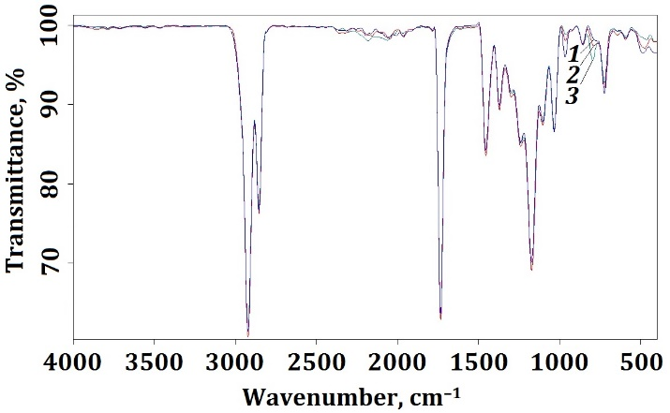
Fig. 1. IR-spectra of eterols-15S obtained at temperature, °C: 160–165 (1); 180–185 (2); 210–215 (3)

The data of 1H NMR spectra for α-benzoins 3a, 4, 5, 12-14 and β-benzoins 6, 7, 16 are given in Table 1.

Table 1
¹H NMR spectral data for α-benzoines 3a, 4, 5, 12–14 and β-benzoines 6, 7, 16

Compounds |  |  | Chemical shift, δ, ppm
№ | X in 4-X-C₆H₄ |  | H_{Fur} |  | C₆H₄ |  | Me₂N
№ |  | H³_{Fur} |  | H⁴_{Fur} | Н^{3,5} | Н^{2,6} | Thienyl-CH₃
α-3a | 2-thienyl |  | 6.31 | 6.47 | – | – | 2.83
α-3a | 2-thienyl |  | 6.39 | 6.49 | – | – | 2.86
α-3a | 2-thienyl |  | 6.39 | 6.49 | – | – | 2.86
Experimental part
1H NMR spectra were recorded on a...
2-Hydroxy-2-(2′′-N,N-dimethylhydrazonyl-5′′-furyl)-1-(2′-thienyl)ethanone-1 (3a). A solution of N,N-dimethylhydrazone furfural (10.0 mmol, 1.38 g) in benzene (4 mL) was added to a solution of 2-thienyl glyoxal (10.0 mmol, 1.40 g) in benzene (14 mL)...
Conclusions
The obtained results allow...
References
- Glover, S. A. (1998). Anomeric amides – structure, properties and reactivity. Tetrahedron, 54(26), 7229–7271.

